Assignment (N+) Day-5(Network testing)
Task-1:
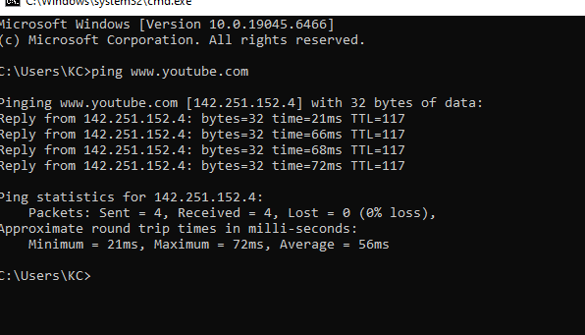

Task-2:
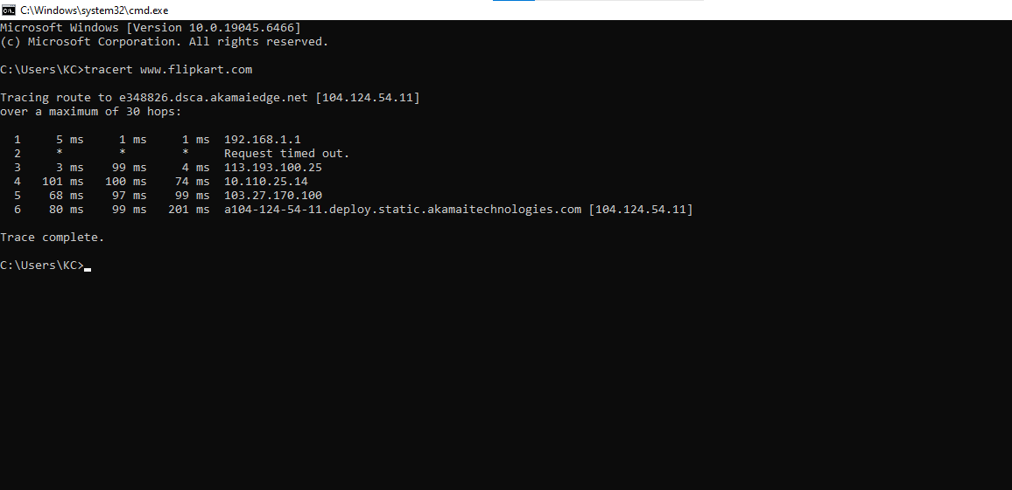

Task-3:
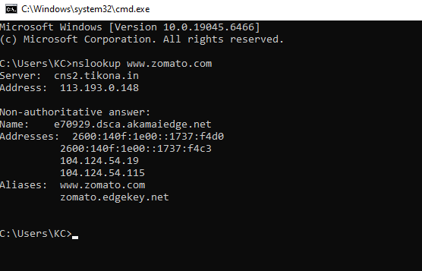

Task-4:
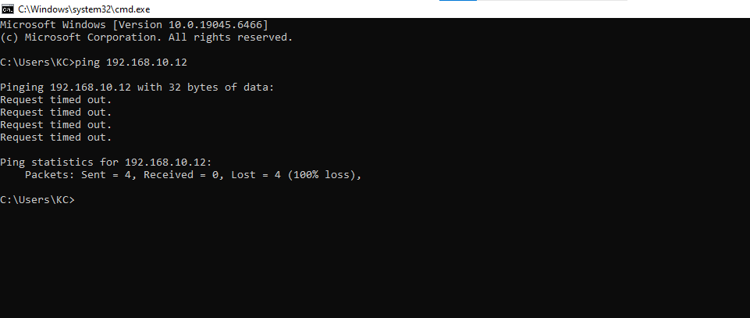
This is the Output when Device is offline.

Task-5:
Website not loading (Ping): Use ping to check if a server is online and reachable. For example, running ping flipkart.com gave successful replies from the IP 23.55.244.176 (which we saw in our Wireshark capture), proving the website was up.
Slow connection (Traceroute): Use tracert (in Windows) to find exactly where the network is lagging. For example, tracert flipkart.com tracked the path to 23.55.244.176, showing the millisecond delay at each router jump so we could spot the exact location of the slowdown.
Suspecting DNS issues (Nslookup): Use nslookup to check if a website name is properly converting into an IP address. For example, running nslookup flipkart.com correctly translated the name to the 23.55.244.176 IP, confirming the DNS server was working perfectly.

